PURPOSE

Asset data is crucial to Glenorchy City Council (GCC) as it serves as the foundation for informed decision-making in our long-term asset planning. This specification applies to subdivisions comprising five lots or more. Upon completion of subdivision works and before the constructed assets are put 'on maintenance' or accepted as practical completion, the Council mandates developers to submit "As-Constructed" drawings and a completed asset data table for relevant stormwater assets. Submissions must adhere to the following requirements.

REQUIREMENT FOR DATUMS

Horizontal Datum: MGA_94 Zone 55
Vertical Datum AHD83

REQUIREMENT FOR SURVEY ACCURACY

Stormwater assets must be surveyed with accuracy, precision and methodologies that align with Quality Level A as per Australian Standard AS 5488.1:2019:

“Describes a below-ground asset that is validated by a series of sub-surface points and surface features with absolute 3D spatial positioning and confirmed attribute information. The maximum allowable vertical and horizontal tolerance is ±50mm.”

REQUIREMENT FOR “AS CONSTRUCTED DRAWINGS”

“As-Constructed" drawings must provide all relevant information regarding the works and be easy to interpret. The minimum standard for "As-Constructed" drawings is demonstrated in the As-Constructed example Drawing, provided as Figure 1 of this document and must include:

- Scale Bar
- North Arrow
- Legend
- Street Names
- Lot Numbers
- Drainage Easements including associated width.
- Reduced Level/Invert Level information on Stormwater assets and include outfalls labelled accordingly.
- Each drawing should be clearly labelled and be noted as "As Constructed.”
- At least two existing GCC Stormwater Assets close to proximity (lid only is sufficient)
- SPM Observation or Local Reference point(s) with MGA_94 coordinates
- Engineers/Surveyors Logo

“As Constructed” drawings must be provided electronically in both .pdf and .dwg formats, unless otherwise approved by Council’s Manager Assets, Engineering and Design.
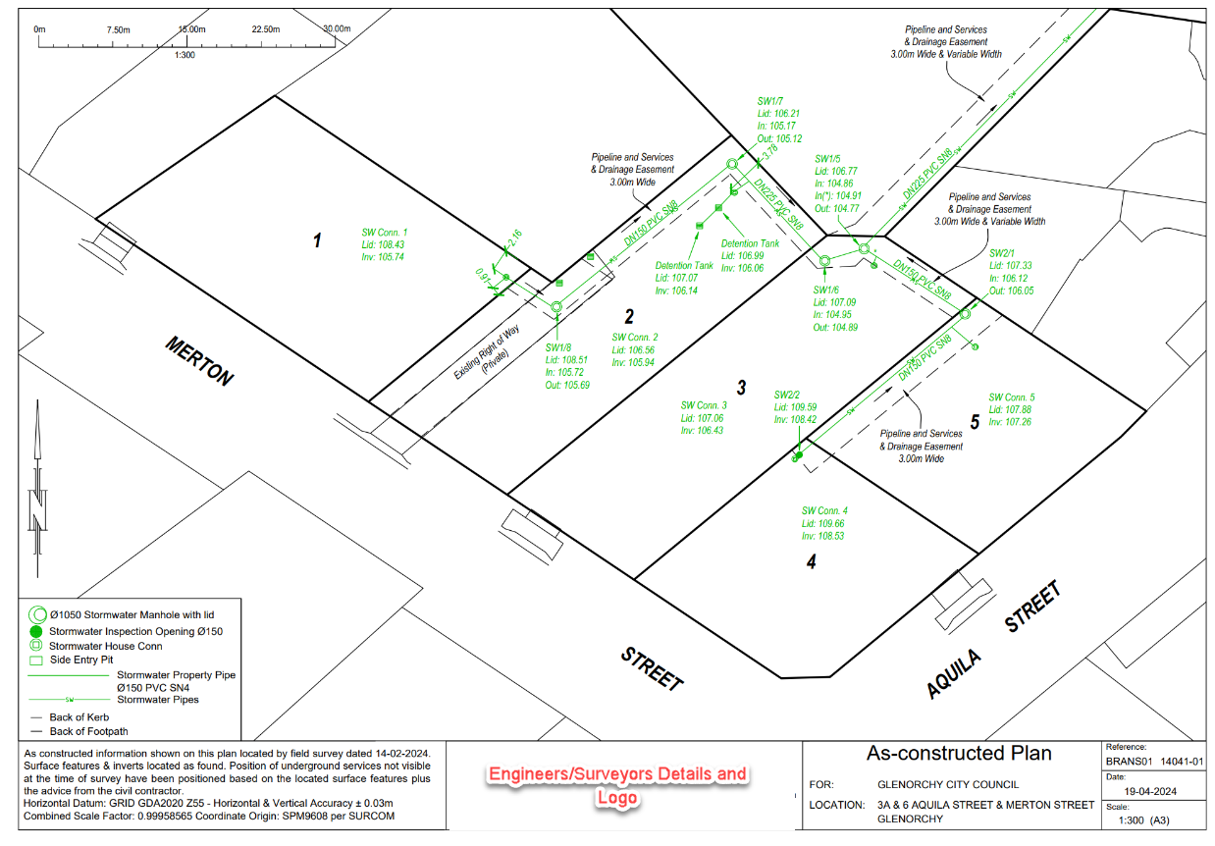
Figure 1: Example of “As Constructed” Drawing

REQUIREMENT FOR ASSET DATA COLLECTION

- The Asset Data Collection must be completed and certified by a suitably qualified engineer or registered surveyor.
- Details on how to complete the Asset Data collection and acceptable values can be found in the following detailed “As Constructed” Asset Data requirement tables and figures.
- The completed Asset Data shall accompany any “As Constructed” drawings.
- The Asset Data must be provided electronically, as part of .dwg file or an Excel document.
- All fields are mandatory (where applicable).
Submitted Stormwater "As Constructed" drawings and completed Asset Data tables must be accompanied by a statement of certification from a suitably qualified engineer or registered surveyor. Practical completion will not be granted until this information is provided to and accepted by the Council.

Table 1: Asset Data required for Stormwater Pits (including Headwall/End wall)

Stormwater Pit (Point Feature) | Description | Attribute
Pit ID | Pit ID on Design Drawing | Text
Pit Type | Type of Stormwater Pit | Text (See Table 2 for details)
Lid Type | The type of lid of the pit / maintenance hole | Text (See Table 3 for details)
Head Wall/End Wall Width | The width of Head Wall and End Wall | Numeric value in metres (See Figure 3 for details)
Out Depth | Depth of Pit from the centre of the lid to the lowest point (the invert of the outflow pipe) | Numeric value in metres
In Depth* | Depth of Pit from the centre of the lid to the (the invert of the inflow pipe)  * Denotes more than one pipe coming into pit | Numeric value in metres
Surface Level | Height of Pit above sea level as taken from the centre of the closed lid or grate | Numeric value in metres

Note: In general, Stormwater Pits will be captured as point features. For a large Chamber Pit, such as a Transition Pit, the perimeter shall be captured as a Polygon, including the access lid as a separate point feature. Additionally, include a photo prior to backfilling so GCC can register it against the Asset. It is desirable to include a time stamp in the photos supplied, not essential.

Table 2: Stormwater Pit Type

Stormwater Pit Type | Description
MH | Maintenance Hole
SEP | Side Entry Pit
GSEP | Grated Side Entry Pit
DGSEP | Double Grated Side Entry Pit
GP | Grated Pit
DGP | Double Grated Pit
GDP | Grated Deflector Pit
TP | Transition Pit
GSD | Grated Strip Drain
IO | Inspection Opening
DE | Dead End (Rod Eye)
HW | Head Wall (Up Stream)
EW | End Wall (Down Stream)
Other | Other Pit Type

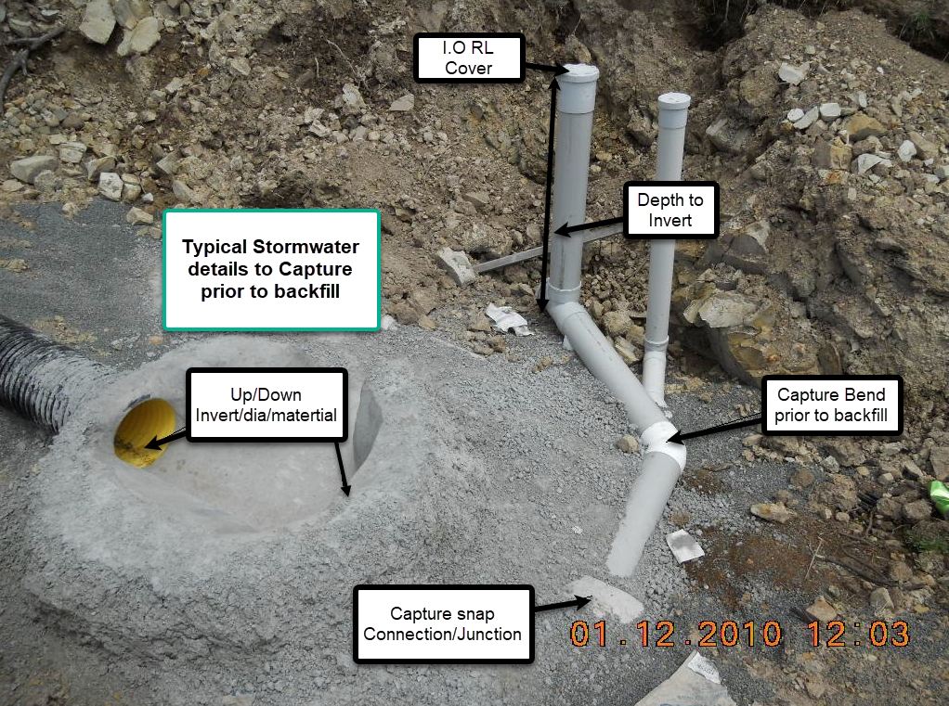
Figure 2: General Pit Arrangement Prior to backfill
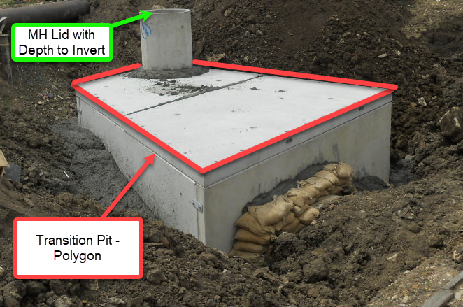
Figure 3: Transition Pit Capture Requirements

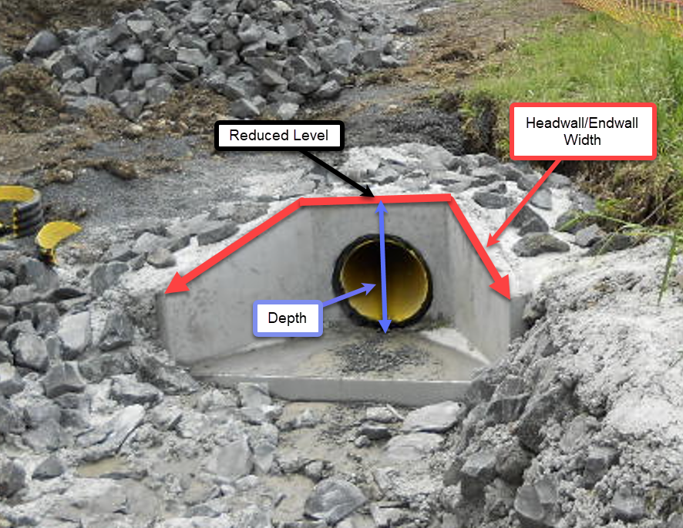

Figure 4: Asset Data required for Stormwater Head Wall/End Wall
Table 4: Asset Data required for Stormwater Drains (including Open Drains etc.)

Stormwater Drain  (Polyline Feature) | Description | Attribute
From Pit ID | Upstream Pit ID on Design Drawing | Text
To Pit ID | Downstream Pit ID on Design Drawing | Text
Pipe Type | Type of the Pipe | Text (See Table 5 for details)
Pipe Material | Material of the pipe | Text (See Table 6 for details)
Pipe Diameter/Width | Internal Diameter of the pipe, If the pipe is rectangular, width and height are to be included | Numeric value in millimetres
Pipe Height | If the pipe is rectangular, width and height are to be included | Numeric value in millimetres
Upstream Depth | Depth in metres of upstream end of pipe | Numeric value in metres
Downstream Depth | Depth in metres of downstream end of pipe | Numeric value in metres
Upstream Invert | Invert level of upstream end of pipe | Numeric value in metres
Downstream Invert | Invert level of downstream end of pipe | Numeric value in metres
Directional change (Property Connections) | Jump up or Horizontal alignment. Survey Node Point for Jump Up. Capture directional change spatially if Horizontal. Capture them prior to backfill | Text

Note: If the pipe is rectangular, width and height are to be included. Ensure that where the Property Connection joins the Gravity Main (i.e., Junction or Connection point), it is accurately picked up prior to backfilling to ensure that the Property Connection is fully within the Lot.

Table 5: Stormwater Pipe Type

Stormwater Pipe Material | Description
Gravity Main | Gravity Main
Box Culvert | Box Culvert
Property Connection | Property Connection
Open Drain | Open Drain

Table 6: Stormwater Drain Material (including Open Drains)

Stormwater Pipe Material | Description
PVC | Polyvinyl chloride
RCP | Reinforced Concrete Pipe
PE | Polyethylene
PPP | High-density polypropylene, i.e. stormrpro / blackmax
RHS | Rectangular Hollow Section
Other | Other Pipe Material

Table 7: Asset Data required for Stormwater Quality Improvement Device (SQID)

Stormwater SQID (Point Feature) | Description | Attribute
SQID ID | SQID ID on Design Drawing | Text
Brand/Model | Brand and Model/Type of GPT | Text (See Table 8 for examples)
Lid Type | The type of lid of the access shaft. | Text (See Table 9 for details)
Outflow Invert Level | Height above sea level of the invert of the outflow pipe | Numeric value in metres
Surface Level | Height of SQID above sea level as taken from the from the centre of the closed lid or grate | Numeric value in metres

Table 8: SQID Brand/Model Examples

SQID Type | SQID Description | SQID Image Example | SQID Model Example
Pit Inserts | ‘Pit Inserts’ is a gully pit insert / basket designed to capture pollution that runs into stormwater drains. It can be installed within new and existing stormwater pits.  Pit Inserts will be recorded in the ‘Stormwater Pits’ table | 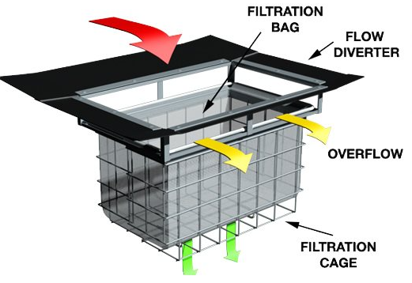 | GP-LT (Grated Pit-Litter Trap)  SEP-LT (Side Entry Pit-Litter Trap)
Gross Pollutant Traps-Wet Sump | Wet storage GPTs are designed to capture and manage large debris, litter, and gross pollutants from stormwater runoff to prevent these pollutants from entering and clogging downstream infrastructure, thus protecting water quality, and reducing maintenance requirements. The wet sump component refers to the design aspect where the collected pollutants are retained in a water-filled chamber, which aids in the separation and settling of pollutants. They are typically underground and require the removal of covers to inspect the level of stored pollutants.  For example: The CDS GPT is to use innovative continuous deflection separation technology, this product effectively traps and removes debris, sediment, and other pollutants from stormwater to improve water quality and protect our environment. | 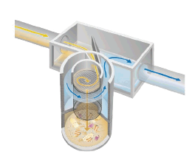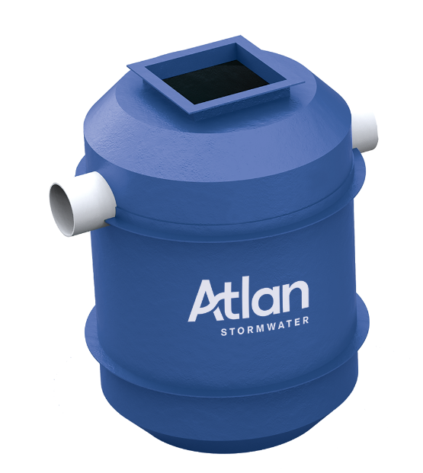 | CDS Units 4500 - C4527 C4530  CDS F0908  Escol RSF4750  Escol RSF4900  Ocean Protect Cascade Jellyfish  Atlan Ecoseptor Votceptor FlowFilter(Hydrosystem)
Gross Traps and Trash Racks-Dry Storage | Dry storage GPTs are consisting of a combined sediment basin and trash rack usually located at the downstream end of a stormwater pipe or a constructed drainage channel. They are designed to capture and remove large debris, litter, and other gross pollutants from stormwater runoff. These devices help prevent pollution, protect water quality, and reduce maintenance needs for downstream systems.  For example, The Ecosol Trash Rack consists of a structurally engineered stainless-steel frame with support legs and a removable heavy-duty UV-stabilised polyethylene filtration net that can be easily lifted out for cleaning and maintenance using a small crane truck. | 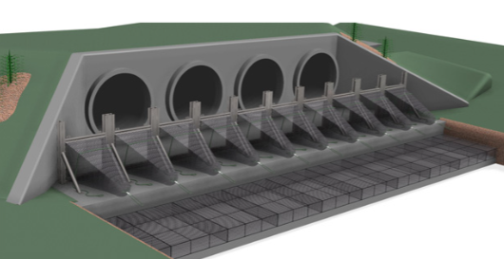 | Ecosol ETR45  Ecosol ETR B37 6  Atlan Bafflebox
Oil and Sediment Separators | Oil and Sediment Separators are designed to remove oil, grease, and sediments from stormwater runoff before it is discharged into natural water bodies or infiltrated into the ground. These separators help protect water quality, prevent pollution, and comply with environmental regulations.  For example, The HumeGard® GPT incorporates a unique floating boom and bypass chamber to enable the continued capture of floating material, even during peak flows. The configuration also prevents re-suspension and release of trapped materials during subsequent storm events. | 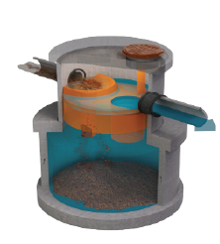 | Humecepter STC2  Humpcepter STC3  Humpcepter STC5  Humpcepter STC7  Humpcepter STC9  Humpcepter STC14  Humpcepter STC18  Humpcepter STC23  Humpcepter STC27  Humpcepter STC40  Humpcepter STC50  Humpcepter STC60  Ocean protect Esk
Cartridge Media Filters | Cartridge Media Filters for stormwater management are specialized filtration systems designed to treat stormwater runoff and improve water quality before it is discharged into natural water bodies or infiltrated into the ground. These filters are part of a broader category of Best Management Practices (BMPs) used to control pollutants and manage stormwater in both urban and rural environments. For example, the Ocean Protect StormFilter® is an underground stormwater treatment device comprised of one or more structures that house rechargeable, media-filled cartridges that trap particulates and adsorb pollutants from stormwater runoff such as total suspended solids, hydrocarbons, nutrients, metals, and other common pollutants. | 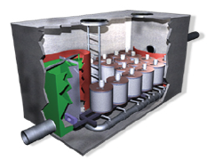 | StomFilter,  Altan filter (Spel Filter)
Floating Booms and Floating Cages | Floating booms are used to control and contain pollutants or debris that may be present in stormwater runoff. They help manage the quality of stormwater by preventing contaminants from spreading and facilitating their collection.  Floating cages are less commonly used in traditional stormwater management but can be adapted for specific applications, such as managing and controlling aquatic plants or debris in water bodies. | 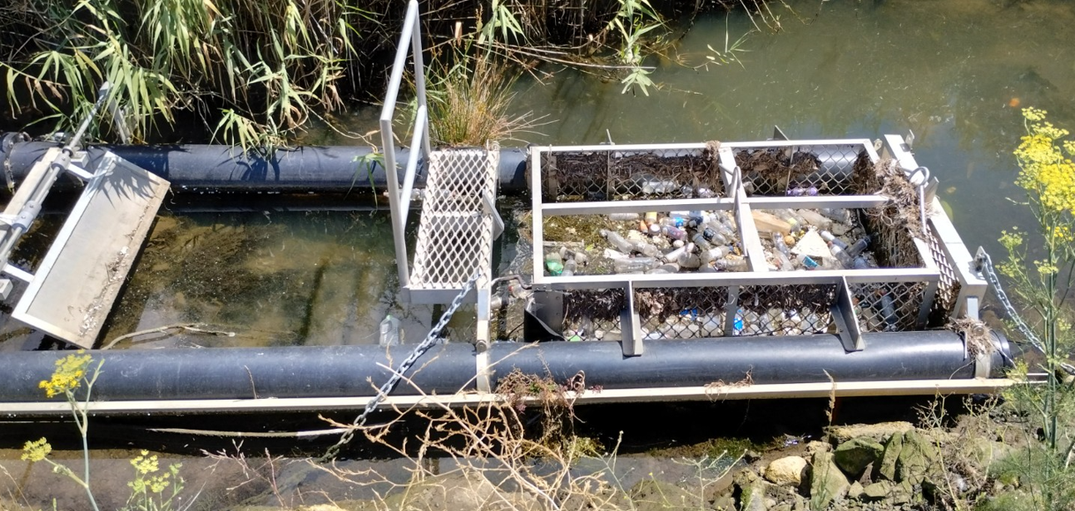 | Bandalong Litter trap
Permeable Pipes | Permeable pipes are specialized types of piping systems designed to allow water to seep through the pipe walls and into the surrounding soil or a designated collection area. They are often used in stormwater management and drainage systems.  Permeable Pipes will be recorded in the ‘Stormwater Drains’ table | 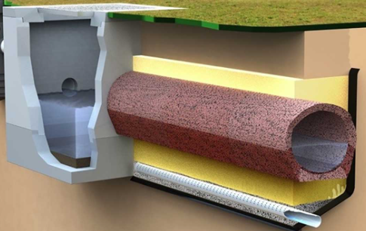 | N/A
Permeable Pavings | Permeable pavings are a type of paving system designed to allow water to pass through the surface and infiltrate into the ground below. This can help manage stormwater, reduce runoff, and support groundwater recharge.  Permeable Pavings will be recorded in the relevant transport tables | 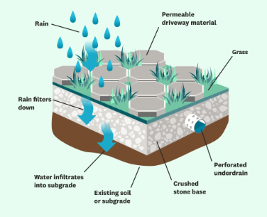 | Truegrid paver  Ecopave
Other SQID Type & relevant models | Other GPT types that are not included in above list | N/A | N/A

Note: Relevant approved maintenance manuals with maintenance schedules for different components of these Stormwater Quality Improvement Devices must be provided to the Council.

Table 9: SQID Lid Type

Stormwater Lid Type | Description
CO | Concrete
STL | Steel
CI | Cast Iron
GA | Gatic style product, steel frame concrete filled
Other | Other Lid Type

Table 10: Asset Data required for Stormwater Storage Basins/Swales
Stormwater Storage Basin/Swale  (Polygon Feature) | Description | Attribute
Storage Basin/Swale ID | Storage Basin/Swale ID on Design Drawing | Text
Storage Basin/Swale Type | Type of the Storage Basin/Swale | Text (See Table 11 for details)
Area of Storage Basin/Swale Type | Area of Storage Basin/Swale Type | Numeric value in square metres

Table 11: Stormwater Storage Basin/Swale Type
Stormwater Storage Basin/Swale Type | Description | Image Example
Retention Basins and constructed wetlands | Retention Basin is an artificial pond with vegetation around the perimeter and a with a permanent or temporary pool or a cascading system of water in its design. | 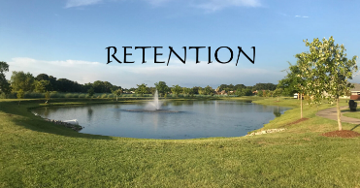
Detention Basin | Detention Basin temporarily stores water after a storm, but eventually empties out at a controlled rate to a downstream water body | 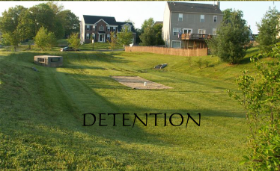
Rain Garden | Rain gardens, also called bioretention facilities, are one of a variety of practices designed to increase rain runoff reabsorption by the soil. They can also be used to treat polluted stormwater runoff. | 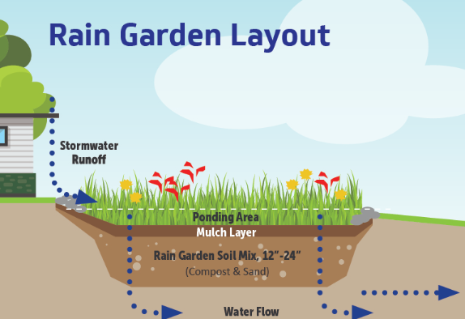
Bioswale | Bioswales are channels designed to concentrate and convey stormwater runoff while removing debris and pollution. Bioswales can also be beneficial in recharging groundwater. | 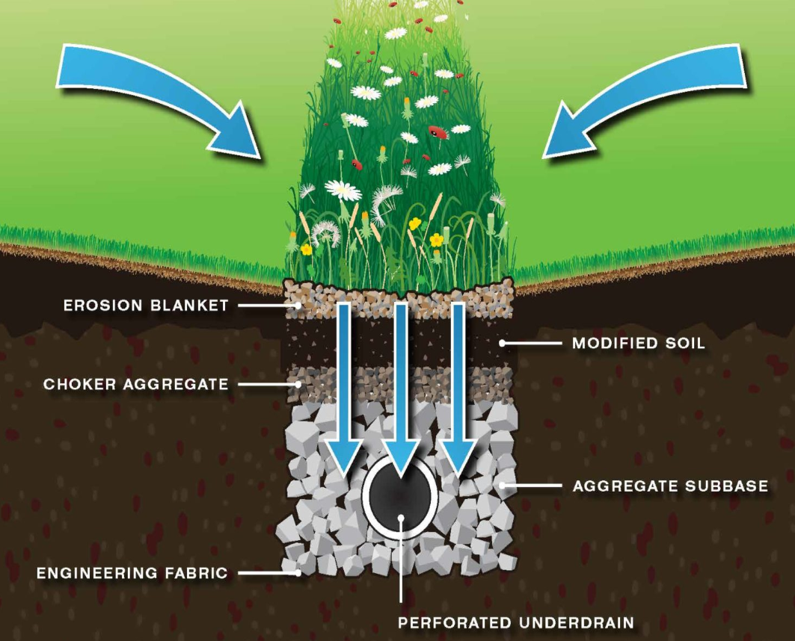

DOCUMENT CONTROL

Version: | 1.0 | Approved |  |  | Commencement Date |  | 01/07/2024
Previous Versions: | N/A |  |  |  | Review Period | 4 Years from adoption
Responsible Section | Asset Section |  |  | Controller: | Manager Assets, Engineering & Design
ECM Document No.:

